“Oh Come In, Equivocator”: Equivocation and Societal Deception in Macbeth
By: Morgan Lewis
In the wake of the 2016 election in the United States, we are forced to look closely at society and examine the causes that led to the election of Donald Trump—a man who speaks offensively, behaves unprofessionally, and has no previous experience in politics. One cry of defense for the man is that he “tells it like it is,” and he “isn’t corrupted by political systems.” After years of hearing political correctness and double-speak from their leaders, Americans yearned for something different, for someone they felt they could trust—and while some feared his divisive rhetoric, for others Trump seemed to be the “different” they sought. However, President-Elect Trump’s recent tweetstorms attacking everything from Saturday Night Live to the cast of Hamilton to the Green Party indicate that he distrusts the very country he will be leading. But this mutual suspicion between leaders and followers is not a new problem.
Shakespeare’s Macbeth addresses this very issue of the people’s distrust in their leaders and the leaders’ fear of their people. Written in 1606, a time of religious, intellectual, and political conflict, the play responds originally to the recent events of the Gunpowder Plot of 1605 and King James I’s subsequent paranoia. Rupert Goold then revived the play on stage in 2008, which was then adapted to film in 2010. Goold places Macbeth in a soviet setting, allowing his audience to draw a parallel between Macbeth and Joseph Stalin, another paranoid tyrant. Through the original text, Goold’s adaptation, and current observations, we see that Macbeth is a history that repeats itself for leaders and followers who do not learn from those who came before; it is a play that we saw acted out yet again on the stage of the 2016 election. The players may change, but the problem remains: a nation founded on paranoia is doomed to devastation.
Shakespeare’s original text alludes specifically to the Gunpowder Plot, which was an attempted assassination of King James I and other political government leaders. It was organized by a group of persecuted Catholics, “embittered by what they perceived as James’s unwillingness to extend toleration to Roman Catholics” (Greenblatt 1343). The group had planned to explode gunpowder beneath the House of Lords, but the night before the plot would ensue, Guy Fawkes was discovered guarding the barrels of gunpowder and the plan was foiled. Father Henry Garnet was a Jesuit Priest who knew of the plot beforehand, but claimed no knowledge of it when interrogated. Garnet was able to lie because of the Jesuit doctrine of equivocation—a document that Garnet authored—which allowed people to withhold truth or speak it in a misleading way without damning their souls, as long as they kept the true statement in their thoughts. In trial, Garnet was found guilty and was prosecuted for his participation in the treasonous plot. As King James I, already insecure about his Scottish heritage, tried to fill the shoes of the revered and heirless Virgin Queen Elizabeth, he developed a deep suspicion that his followers were plotting against him. While some hold that Macbeth was written to reassure King James I that, as a believed descendent of Banquo, he was the rightful heir to the throne, the king shares enough paranoid tendencies with Macbeth that the play seems to pose two options for the newly ordained king: he can be a leader like Macbeth, or he can be a leader like Banquo.
Rupert Goold, inspired by the complex relationship of England and Scotland during Shakespeare’s time, set his adaptation in soviet Russia at a time when English and Russian relations were also complex. In an interview on Theater Talk, Goold admits,
I was interested in…a sort of semi-soviet world. I was interested in what Scotland meant to England in Jacobean society. There was beyond Hadrian’s Wall, like what was beyond the Iron Curtain for the West, a sort of hinterland where strange and tyrannical things were supposed to happen in…the English subconscious. I was interested in a world where there are ‘daggers in men’s smiles’…that there’s a sort of double-speak used for people being able to think but dare not speak. (Theater Talk)
Goold’s soviet theme is supported by the imagery in the film: the frequent splash of bright communist red, the portrait of Macbeth at dinner reminiscent of famous portraits of Stalin, and the montage of executions, bourgeoisie dinner preparations, and firsthand film footage from soviet Russia set the stage for Macbeth to embody the historic figure of Stalin.
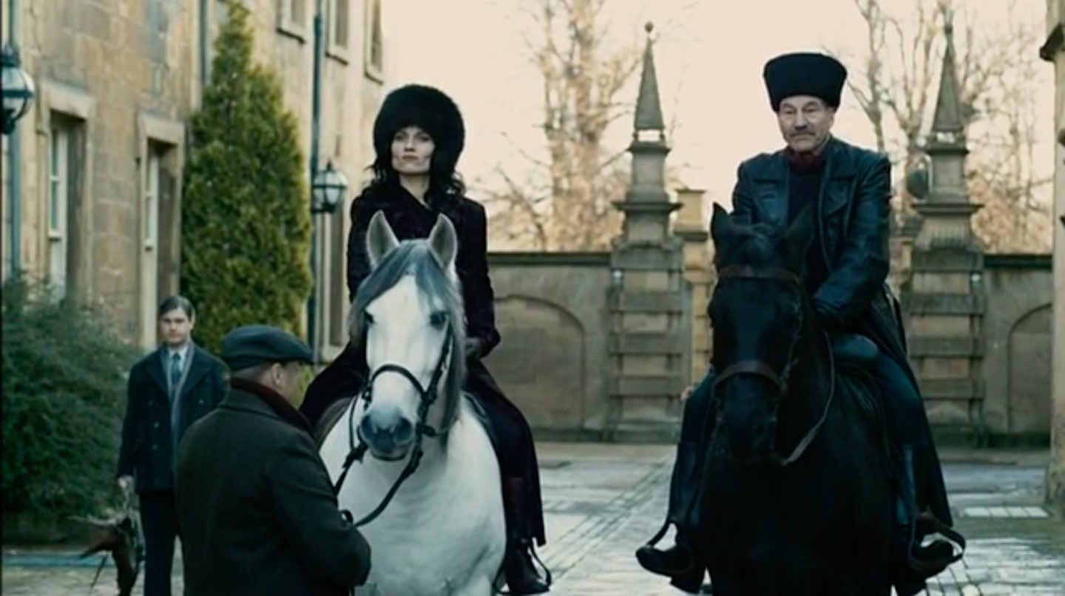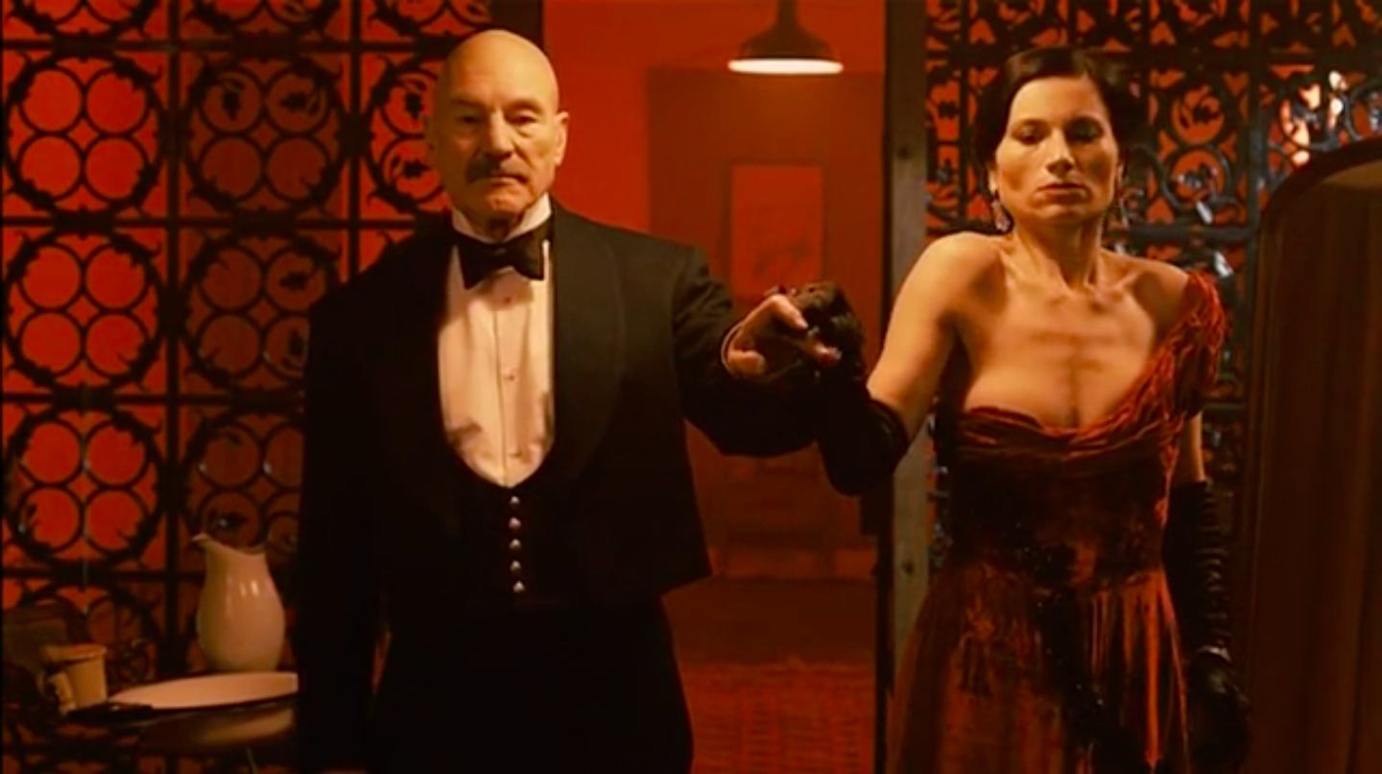
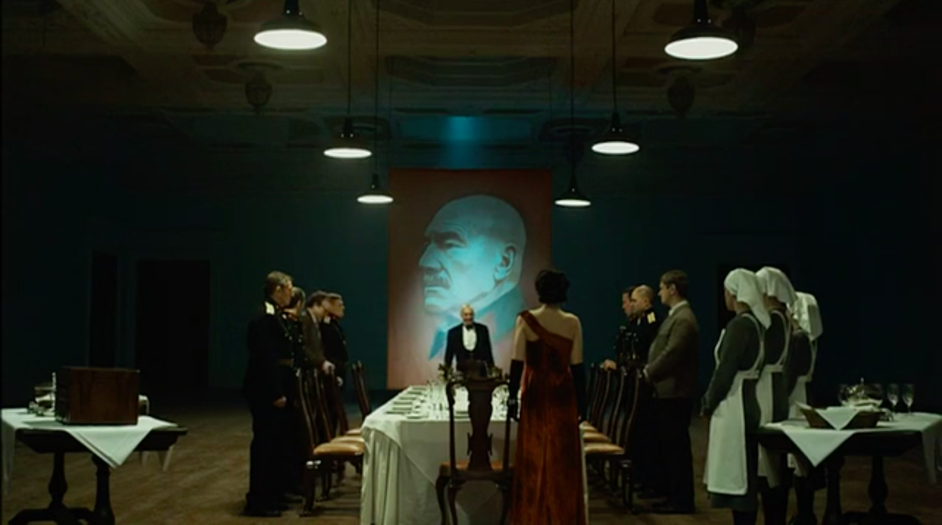
The personal lives of Macbeth and Stalin eerily coincide as well—for example, both Lady Macbeth and Stalin’s second wife, Nadezhda Alliluyeva, committed suicide. According to Rosamond Richardson, “[Nadezhda] had publicly said, by leaving a letter, that she thought that Stalin’s policies were wrong…and that she found it intolerable and she couldn’t live with it and she would commit suicide” (Bulley, Stalin: Inside the Terror). Nadezhda’s guilt-driven suicide reflects Lady Macbeth’s last scene as she madly scrubs her unclean hands in her sleep, lamenting that “all the perfumes of Arabia will not sweeten [her] little hand” (5.1.42–3).
These imagistic and historical connections lead the audience to see the similarities in Macbeth and Stalin’s totalitarian leadership styles. In his article, “Hitler, Stalin, and Shakespeare's Macbeth: Modern Totalitarianism and Ancient Tyranny,” Roland Mushat Frye explains, “Stalin developed a steadily lengthening list of ‘enemies,’ whether potential, real, or imaginary, and Stalin operated on the assumption that it was better to kill too many than too few” (100). Macbeth uses this same methodology in determining to kill Banquo and his son. Though the witches’ prophecy explicitly states that Banquo will not become king, Macbeth sees it fit to send murderers after both Banquo and his son Fleance, saying, “To be thus is nothing / But to be safely thus. Our fears in Banquo / Stick deep, and in his royalty of nature / Reigns that which would be feared…There is none but he / Whose being I do fear” (3.1.49–57). However, being king means nothing to Macbeth until he is entirely certain that nothing can overthrow him and he relies on the witches’ prophecy to determine those threats. He fears Banquo’s naturally noble temperament, and sees it necessary that both he and Fleance be removed as potential dangers to his power. And although Macbeth insists that Banquo is the only man whom he fears, Macbeth goes on to ruthlessly kill Lady Macduff and her children—innocent people who posed no threat to his throne. Goold’s film depicts this attitude with a montage before the dinner preparations that depicts executions and soldier marches juxtaposed with perfectly aligned silverware and a vat of blood-red soup. These disturbing images give the impression that Macbeth kills many more people on his ascent to power than are mentioned in the play. The implication of mass-murder more closely aligns him with Stalin, who killed millions through executions, exiles, and starvation.
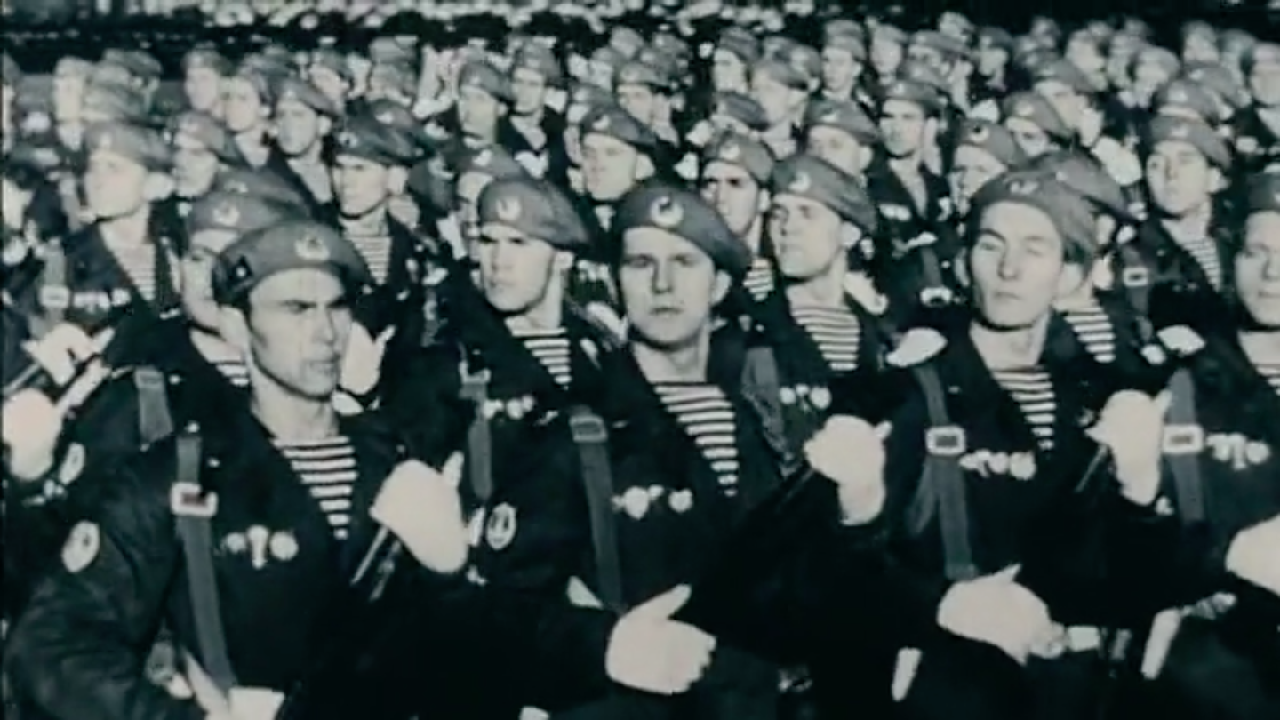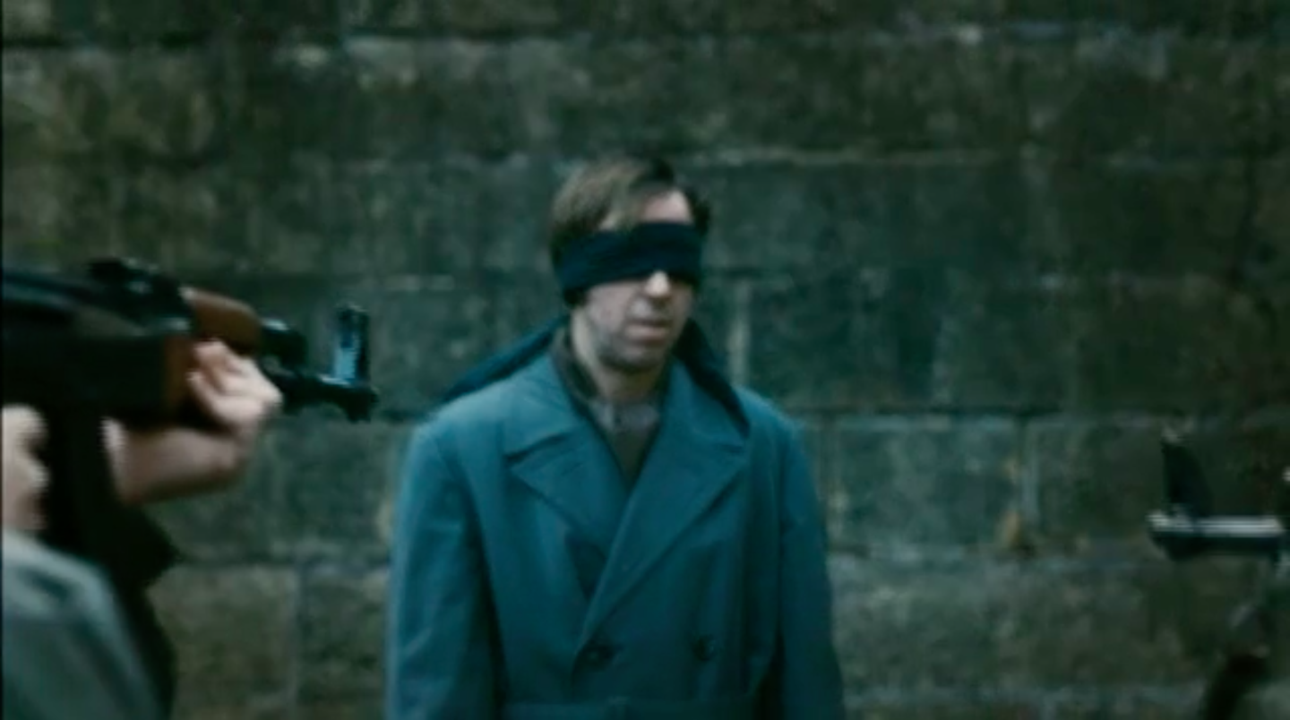
The common thread of all corrupt leaders is the tendency to double-speak, equivocate, or outright lie to gain power. Shakespeare explicitly condemns this practice by invoking the Gunpowder Plot in the porter’s speech. In examining the text, it’s important to note that the speech is given by one of Shakespeare’s “clown” characters. The porter is meant for comic relief, and yet his humor is dark and the there is an element of truth to his words. Rhodes and Gillespie observe that theatrical clowns were symbols of pop culture and the meshing of high and low society. They played idiots or country bumpkins, but spoke of educated matters, opening the door for a subversion of societal expectations. Furthermore:
The figure of a clown could have been practically invented to muddle matters further, pointing as it does in two directions—on the one hand, towards a clarity of social distinctions and on the other, towards a messy reality in which the relationship between individuals and the labels applied to them is often imprecise, potentially unstable, and even downright deceptive. The interest of Shakespeare’s clowns lies precisely in the ways in which these two senses are played off against each other, in a series of increasingly complex variations upon a theme. (75)
The clowns in Shakespeare were presented by characters of low societal rank, characters who wouldn’t typically be taken seriously. However, these characters—though they frequently exploit vulgar vocabulary of their societal rank—often speak to questions that Shakespeare embeds in the heart of the play. In this case, the porter is a lowly servant who verbalizes themes of equivocation and the deception of societal labels through an allusion to the controversial Gunpowder Plot.
The scene begins with a knocking immediately after Macbeth and Lady Macbeth have carried out their first murder plot. The porter speaks, “If a man were porter of hell-gate, he should have old turning the key,” which launches him into a hypothetical scenario in which he, like St. Peter at heaven’s gate, plays the role of gatekeeper of hell, crying, “Who’s there i’th’ name of Beelzebub?” instead of in the name of God (2.3.1–3). The porter then welcomes in three people: a farmer who stashed grain to sell at a higher price, but was ruined by a crop surplus; an equivocator who committed treason; and a tailor who skimped on cloth in pants he made. In each circumstance, the subject is withholding something necessary, which must be considered sin because each is beckoned to hell by the porter.
The audience of Shakespeare’s time would have immediately recognized the second man, the equivocator, as Father Henry Garnet, who had been prosecuted for committing “treason enough for God’s sake, yet could not equivocate to heaven” in the Gunpowder Plot within that year (2.3.9–10). It is strange, then, that the porter makes such a definitive claim on the priest’s salvation, for Garnet would have occupied a much higher position in society than the porter would. As a priest at the time, Garnet would also have been considered more holy than the general population, for it was through his priesthood that the laity could access the rites to salvation. Yet, the porter—a symbol of subverted societal expectation himself—exposes the priest for his corruptions, further supporting the way in which clowns reveal the imprecise, unstable, and deceptive relationship between people and their social labels, as suggested by Rhodes and Gillespie above. The porter not only shows the complicated nature of this relationship, but actually reverses audience expectations when he says, “I had thought to let in some of all professions that go the primrose way to th’everlasting bonfire” (2.3.16–18). The primrose way alludes to Matthew 7:13 in the Bible, which teaches that “wide is the gate and broad is the way that leads to destruction, and many enter through it.” The porter then, through invoking holy scripture, becomes the heightened moral figure condemning the priest for his sin of equivocation.
The problem of equivocation and the foundation of distrust is not only a central theme in Macbeth, but the catalyst for the horrendous tragedies that brought about Macbeth’s rise to power and downfall. The prophecies of the weird sisters, for instance, intentionally misled Macbeth to believe that no man stood in the way of his ascent to power, for every man alive is born of a woman and trees cannot physically displace themselves. Donalbain, too, refers to the common thread of deceit within the play when he suggests that he and Malcom flee for “Where [they] are / There’s daggers in men’s smiles” (2.3.135–6).
The porter, then, acts as a translator for Shakespeare’s audience so they could make the connection of equivocation to their own society at the time. The equivocating priest first reflects on Macbeth’s betrayal of his noble title and corruption to ascend to power. In this way, the porter’s condemnation of the priest, and therefore Macbeth, acts as a warning to King James I for his paranoia that his power would be overthrown. This passage shows King James that while some skepticism is justified (as proven in the Gunpowder Plot), if he goes too far in his distrust, he will spiral out of control just as Macbeth did, and all of England will suffer. At the same time, the priest represents a disloyal servant who placed the future of the country in danger for his treasonous actions. In other words, the porter at once represents the corruption and distrust of both leaders and followers, and as the audience holds these images simultaneously in their minds, they must ask themselves—what are the implications on one’s personal salvation and on society as a whole when someone of any societal status equivocates and plots for their personal gain?
Rupert Goold’s adaptation of Macbeth further underlines the theme of equivocation and the betrayal of societal positions in his version of the porter’s speech. However, Goold does not portray the porter as a humorous clown figure, but as a haunting figure of admonition for the viewers and the equivocators he implicates.
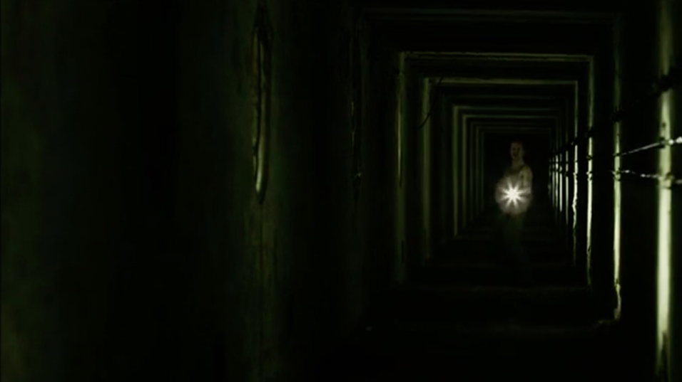
The porter is a grimy character, who gives his speech without even a hint of humor alone in a dark hallway with periodic lights that seems to lead for eternity into a black vanishing point behind him. When the porter implicates the equivocator, as he speaks, “who could not equivocate to heaven,” the camera racks the focus from the porter to the vanishing point behind him and the viewer realizes two things. First, that the vanishing point, although dark and distant, represents the desired destination—heaven. Second, viewers recognize their own position in relation to heaven; the audience is at the opposite end of “heaven”, meaning we are either currently in hell, or close to it. This realization is further punctuated when the viewer loses sight of the distant heaven to solid blackness behind the porter as he claims that he “had thought to have let in some of all professions that go the primrose way to th’everlasting bonfire.” The vanishing point visual works again to show viewers that they are positioned at the point where the path is widest, a long distance from the strait and narrow way leading to the vanishing point, or heaven. In other words, viewers are implicated right along with Macbeth for our complicity in his crime, and we are subject to the same condemnation. Additionally, because Macbeth represents Stalin in this film, the audience is then complicit in the terror that occurred under his regime—if not through inaction during the events, then through forgetting them less than a century later.
Goold subverts the audience’s expectations for porter’s character and demonstrates that he has the moral capacity to dole out this condemnation through very specific lighting choices. The porter carries a flashlight throughout this scene, shining it at the camera as if to examine the audience. Light is often a symbol for enlightenment or revelation. As the porter shines his light onto the audience, he is inviting them to analyze themselves and their own state of guilt. He holds the light source, implying that he is in a position of power. When the viewers lose sight of the vanishing point (which has periodic lights leading up to it) to total darkness, the porter is the only source of light. He seems to glow yellow, invoking the image of a celestial being—an striking contrast to his filthy appearance. By illuminating the porter, Goold shows that the character is a kind of moral compass. As gatekeeper of hell, he has as much power as St.
Peter to usher people in to damnation or turn them away to salvation. As he beams his flashlight into the camera and onto viewers, he becomes a reminder that to the viewers that what they do—and what Macbeth has done—has eternal consequences.
With these associations in mind, the porter scene becomes a frame for the rest of the film. The porter foreshadows the destruction that is soon to come to Macbeth—not just mortally, but eternally. The porter closes this scene by looking directly at the camera and warns, “I pray you remember the porter.” The porter places heavy emphasis on the last three words, turning his request for a tip into a chilling message that lingers as the viewers stand by to watch Macbeth bring about his own destruction and eternal damnation, falling so far from of the view of heaven that he loses all perspective to a vast expanse of pitch black.
The porter’s scene as portrayed by Rupert Goold then casts a dark shadow on Ross’s advice to Lady Macduff as she mourns her husband’s absence, “But cruel are the times when we are traitors / And do not know ourselves; when we hold rumour / From what we fear, yet know not what we fear, / But float upon a wild and violent sea / Each way and none” (4.2.18–22). Ross, in the last two lines of this passage, seems to allude to Ephesians 4:11–14, which reads:
And he gave some, apostles; and some, prophets; and some, evangelists; and some, pastors and teachers; For the perfecting of the saints, for the work of the ministry, for the edifying of the body of Christ: Till we all come in the unity of the faith…That we henceforth be no more children, tossed to and fro, and carried about with every wind of doctrine, by the sleight of men, and cunning craftiness, whereby they lie in wait to deceive. [Emphasis added]
It’s important to note that in Shakespeare’s day, the king was another religious leader and was seen as divinely ordained to his role. Given the context of the scripture and the porter’s definitive condemnation of leaders who equivocate and betray the responsibilities of their social title, Ross’s words further condemn Macbeth—and therefore the equivocating priest—for their deception. Both men are leaders who are supposed to unify their people, but who choose self-interest over the good of the country, which leads to the country’s demise. It falls on the nation’s leader to guide it safely through the stormy seas, and betraying that calling is a grievous sin certain to send the perpetrator to hell’s gates, welcomed by the devil’s porter.
With each tyrant that corrodes a nation, parallels are drawn to previous totalitarian disasters, and society swears to never return to that place. We look back at the Nazi regime and wonder how they could have fallen for Hitler’s blatant anti-Semitism. We wonder how Russians could have justified murder in favor of the “greater good” rhetoric of Stalin. And yet Americans find ourselves with a President-Elect who denounces Muslims, Syrian refugees, Mexican immigrants, and anyone who voices opinions contrary to his own. We are once again in a precarious situation with a leader suspicious of “rigged elections” and “biased media,” but who has not earned the people’s trust himself. It is narcissistic bullies like these who are fated to repeat the cycle of destruction for the nation they lead. It’s no wonder that historians worry for the future of our country.
But it is because society repeats this cycle that scholars are able to continue learning from Shakespeare’s works. Frye claims, “[Shakespeare’s] genius included an instinctive grasp of what is perennial in human nature, whatever the particular historical circumstances of numbers counted” (103). Shakespeare was able to capture those common threads of the tragedies that repeat themselves. His characters embody the human condition in such a way that transcends the bounds of time and circumstance. And, as humanity fails to learn its lesson over and over again, Shakespeare’s plays will continue to hold relevant messages for centuries to come.

Works Cited:
Frye, Roland Mushat. “Hitler, Stalin, and Shakespeare's Macbeth: Modern Totalitarianism and Ancient Tyranny.” Proceedings of the American Philosophical Society, vol. 142, no. 1, 1998, pp. 81–109. JSTOR. Accessed 2 December 2016.
Goold, Rupert, and Patrick Stewart. Interview by Michael Riedel and Susan Haskins. Theater Talk. 18 Apr. 2008. Web. Accessed 3 Dec 2016.
Greenblatt, Stephen. “Macbeth.” The Norton Shakespeare. Ed. Stephen Greenblatt, W.W. Norton and Company, Inc., 2009. 1343–51. Print.
Macbeth. Directed by Rupert Goold. BBC Four, 2010.
Rhodes, Neil, and Stuart Gillespie. Shakespeare And Elizabethan Popular Culture: Arden Critical Companion. London: Arden Shakespeare, 2006. eBook.
Shakespeare, William. Macbeth. The Norton Shakespeare. Ed. Stephen Greenblatt, W.W. Norton and Company, Inc., 2009. 1353–1406. Print.
Stalin: Inside the Terror. Directed by Tony Bulley. Granada Productions, 2003.
The Bible. Authorized King James Version, Oxford UP, 1998.

